XTOPEL POWER LIMITED
(SUPPLY, INSTALLATION AND MANAGEMENT OF PREPAID ELECTRICITY SUB-METERING AND VENDING SOLUTIONS)

TECHNICAL AND FINANCIAL PROPOSAL

SUPPLY, INSTALLATION AND MANAGEMENT OF SMART KEYPAD PREPAID ELECTRICITY METERS WITH VENDING MANAGEMENT SYSTEM

FOR

NATIONAL COMMUNICATION AUTHORITY (NCA) FACILITIES

APRIL, 2026

Submitted By:

Xtopel Power Limited
P. O. Box TF 425,
Trade Fair, Accra.
Tel: Office: +233-242-046-983, 0277-784-431, 0243-133-411
Email: info@xtopel.com; Website: www.xtopelpower.com

Submitted By
Peacefield Link Ventures
P. O. Box DC 959
Dansoman, Accra.
Tel: 233-244236566

Table of Contents
1.0 National Communication Authority Prepaid Electricity Sub-Metering Project 3
1.1 Objective of the Prepaid Sub-metering Electricity Management Solution 3
1.2 Xtopel Electricity bill management solution 3
1.3 Technical Approach and Implementation Plan 4
1.4 The Smart Keypad Prepaid Electricity meters 5
The Dual Power Source Meter operating principle 5
1.5 The Smart Prepayment Keypad Electricity Meters 5
1.7 The Meter functionalities 10
1.8 Payment Methods and Payment of Outstanding Bills 11
1.9 Tariff Structure 12
2.0 Key Milestones and Timelines 12
3.0 Financial Proposal 13
3.1 Price Schedule 13
3.2 Software as Service (SaaS) and IT Infrastructure Management 13
4.0 About Xtopel Power Limited 14
4.1 Sample of Selected Relevant Projects Undertaken by the Firm 14
Services offered by Xtopel Power 15
5.0 XTOPEL SUB-METERING PROJECTS IN PICTURES 16

National Communication Authority Prepaid Electricity Sub-Metering Project

Xtopel Power Limited extends its compliments and is pleased to submit our proposal to supply, install and manage the deployment of Smart keypad Prepaid Electricity sub-metering and vending system for the National Communication Authority (NCA) facilities.

1.1 Objective of the Prepaid Sub-metering Electricity Management Solution

The overarching objective is to decentralize the facility-wide utility bill management system and transfer responsibility of management and control of power consumption (kWh) and its payment (GHS) to downstream electricity consumers.

Specifically:

- Eliminate permanently the inability to scientifically measure the actual consumption of power (kilowatt-hour) of tenants accurately
- Eliminate the manual calculation, distribution, and collection of electricity bills to tenants permanently and enhance the timely payment of bills on due dates.
- Eliminate the burden of looking for cash to pay the ECG bill by facility managers
- Deliver a solution that guarantees near 100 per cent electricity bill revenue assurance
- Ensure that all tenants pay for their electricity consumption before they use the power.
- Ensure tenants with high-consuming equipment pay an equivalent amount in Ghana Cedis to the volume of power they consume.

1.2 Xtopel Electricity bill management solution

Xtopel Power’s electricity management solution employs a highly efficient Automatic Meter Reading (AMR) electricity vending and billing system and operates on a cutting-edge highly effective Automatic Metering Infrastructure (AMI) tool that facilitates the prepayment, bill measurement and control for sub-metering of bulk or shared meters for down-stream utility consumers.

We offer an electricity power management solution that delivers monthly revenue cashflow benefits to SLT bulk meter commercial facility owners and managers.
The solution provides a 24-hour and seven (7)-days a week power (credit) purchase and payment for electricity through our independent web-based Vending and billing management system. The system has the capability to sell power and collect cash from each shop owner for power purchased before the power is consumed.

The Vending software provides the following capabilities:

- The capability of enabling pre-payment of power purchases using the Public Utility Regulatory Commission (PURC) approved tariff integrated into the vending system.
- Generates a 20-digit token code for power purchased to recharge shop owners meters using the keypad on the meter or the customer interface unit (CIU) by the shop owners.
- Remote control of meters enables meters to be switched On or Off remotely in case it is detected that power is being stolen.

1.3 Technical Approach and Implementation Plan

Technical Approach
The precondition for the efficient deployment of the proposed sub-metering system requires adequate provision of power supply to all-metering points into DBs to facilitate the installation of unique pre-paid meters. The Power supply and separation must be as comprehensive as possible to eliminate any form of power leakage. The following tasks will be performed:

- Assessment of the electrical wiring architecture for sub-metering wiring requirements and perform power supply separations (if any).
- Confirm the quantity of metering points for single-phase, three-phase, CT meters and DCU.
- Provide wiring materials estimates for the metering points and submit Bill of Materials and metering equipment to Contractor Ltd.
- Conduct procurement of wiring materials and prepaid metering equipment.
- Execute the installation of the Kumasi Central Market Sub-metering system.

Implementation Plan

The following key Activities and tasks will be undertaken to execute the installation of the Sub-metering system.

- Perform power supply and separation of metering points of the sub-metering system (if any)
Task: Undertake power supply, separation and wiring of metering points identified (if any)

- Execute the installation of pre-paid meters and equipment of the sub-metering system
Task 1: Undertake the installation of single-phase, three-phase, and CT meters and DCUs

- Set up the independent vending and bill management system
Task 1: Create the NCA submetering Account on the AMI website
Task 2: Register all prepaid meter accounts on the meter management system.
Task 3: Register all tenants on the customer management system
Task 4: Register all tenants' accounts on the accounts management system
Task 5: Develop the PURC Tariff Structure on the vending system

- Perform pilot testing of the pre-paid sub-metering and vending management system
Task 1: Activate all shop owners accounts on the vending system
Task 2: Undertake testing of credentials of the pre-paid meters, CIU, and the DCU

- Commissioning of the NCA sub-metering and vending management system
Task 1: Train NCA Property Management (or staff) on the operations of the billing and vending management system
Task 2: Conduct a sensitization meeting for tenants on the electricity pre-payment and bill management system.
Task 3: Perform official handing over of the sub-metering and Vending management system.
Task 4: Signing of service level agreement (SLA) for the management and maintenance of the sub-metering and vending management system.

1.4 The Smart Keypad Prepaid Electricity meters

The components of the Utility bill management solutions comprise:

- The Smart keypad STS prepaid electricity and water meters
- The customer/user-interface unit (CIU/UIU)
- The web-based independent vending management system
- The data concentrator unit (DCU)

The Dual Power Source Meter operating principle

The dual-source meter is a HIGH-END meter that enables pre-payment for the cost of power (Ghana Cedis) equivalent to the quantity of power (kilowatt-hour) consumed for both ECG power and Generator power sources.

When a power outage occurs and the ECG grid power source goes off, the meter automatically switches from the ECG power supply to the Generator power supply, picks up the signal from the Changeover, and immediately transmits the Genset power source. ONLY tenants who have purchased Genset power and pre-paid on their Dual Tariff meters will be connected to the power supply from the Generator.
Tenants without Genset power credit will have to buy a quantity of Genset power (kilowatt-hour) and pre-pay the equivalent amount (Ghana Cedis) and load the credit tokens to their dual tariff meter for connection to the Genset power supply.

1.5 The Smart Prepayment Keypad Electricity Meters

The smart meters work with a plug-in module for DLMS/COSEM compliant data collection and network communications. This design enables the selection options from PLC/RF communication.
The Single-Phase Dual Source Keypad Energy Prepaid Meter
This single-phase power source is a 2-wire split type of prepayment keypad electricity meter and provides reliable and accurate metering applications. The meter comes with a separate display and keypad customer interface unit (UIU/CIU). It is an ideal revenue protection metering tool that measures grid power and disconnects power when credit finish.
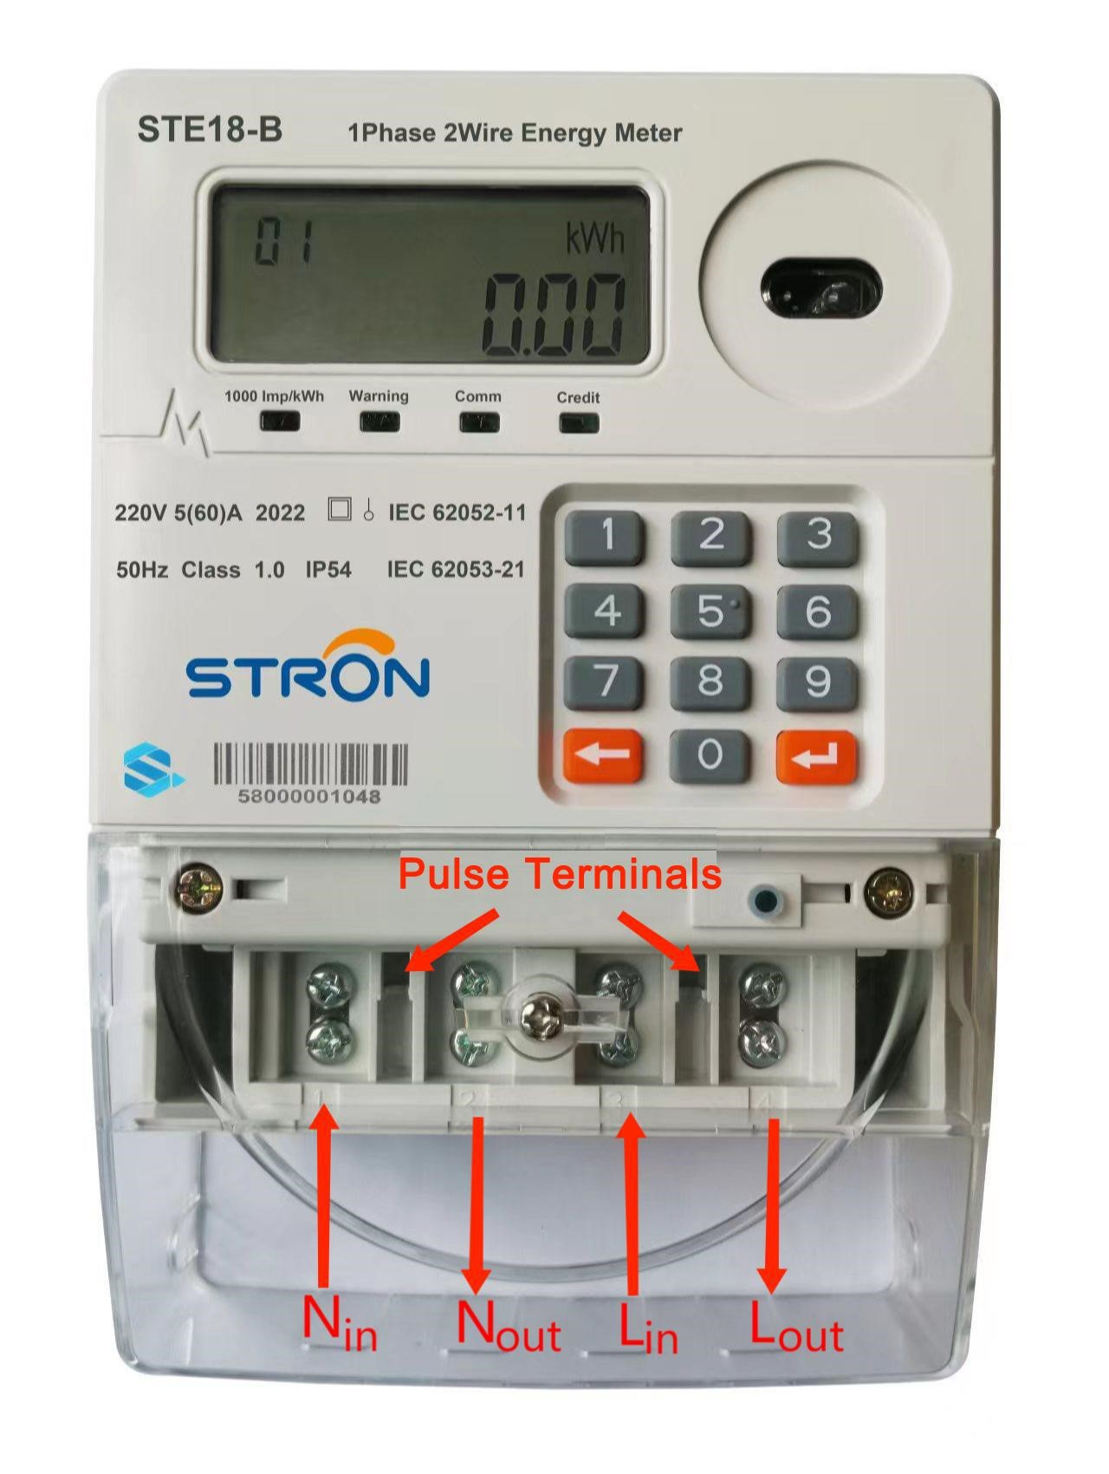
Single-phase meter comes with CIU

Technical Data Sheet of Single-Phase meter
Item Number | STE18-B
Norminal Voltage | 230V
Working Voltage Range | 70%~120%Un
Frequency | 50Hz
Basic Current (Ib) | 5A
Maximum Current (Imax) | 60A
Starting Current(Ist) | 20mA
Active Energy Constant | 1000imp/kWh
Measuring Accuracy | Class 1.0
Power Consumption in Voltage Circuit | <2W <8VA
Power Consumption of in Current Circuit | <1VA
Operation Temperature Range | -25℃-70℃
Storage Temperature Range | -40℃-85℃
Communication | 433RF
Dimension | 180.2mm×120mm×55.7mm
Weight | 0.465kg
Waterproof Level | IP54
Battery Voltage | 3.3V
Sleep Current | 0.2mA
Electromagnetic Compatibility
AC Insulation Strength |  | 4kV /  1min | 50Hz | during
Impulse voltage1.2/50 us mains connection |  | 8kV
Electrostatic Discharge | Contact Discharge | 8kV
 | Air Discharge | 16kV
Insulation Electromagnetic RF Field | 27MHz-500MHz | 10V/m
 | 100KHz-1GHz | 30V/m
Fast Transient Burst Test |  | 4kV
Protection level |  | Class II

4.3 The Three Phase Dual Source Prepayment Keypad Electricity Meter
The Three phase meter is a HIGH-END four-wire with up to 100 Amp per phase keypad prepayment meter. The meter is best choice for large residential houses, small commercial and industrial applications. It is an ideal revenue protection metering tool that measures grid power and Generator power simultaneously with no need of adding extra components and disconnects power when credit finish. In the dual pre-paid mode, the meter can auto decrypt the recharge code from different source and top-up into separate balances.
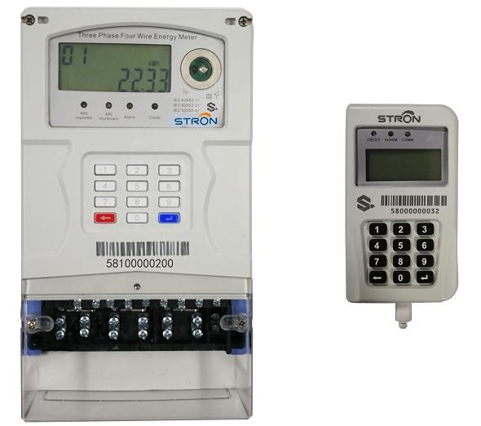

Three-phase meter with CIU

The Technical Data Sheet: Three-phase Meters
Nominal Voltage | 3×230V/400V
Working Voltage Range | 70%~120%Un
Nominal Frequency | 50-60Hz
Basic Current (Ib) | 10A
Maximum Current (Imax) | 3×100A
Starting Current (Ist) | 30mA
Active Energy Constant | 400imp/kWh
Active Energy Accuracy | Class 1.0
Reactive Energy Accuracy | Class 2.0
Power Consumption in Voltage Circuit | <2W <8VA
Power Consumption in Current Circuit | <1VA
Operation Temperature Range | -25℃-70℃
Storage Temperature Range | -40℃-85℃
Electromagnetic Compatibility
AC Insulation Strength |  | 4kV at 50Hz during 1min
Impulse voltage 1.2/50 us mains connections |  | 8kV
Electrostatic Discharges | Contact discharge | 8kV
 | Air discharge | 16kV
Electromagnetic RF Field | 27MHz-500MHz | 10V/m
 | 100KHz-1GHz | 30V/m
Fast transient burst test |  | 4kV
Protection |  | Class II

4.4 Three-Phase Low Voltage (LV) CT Prepaid Energy Meter

The 3-phase 4-wire Low Voltage CT prepaid meter unit is equipped with a high precision smart energy meter, which comply with STS standard and have a plug and play communication module for remote reading and controlling, with a breaker. This 3-phase 4 wire CT is ideal for metering high power consuming commercial and industrial facilities and is ideal for energy loss reduction and revenue protection. This modular design enables utility to select from 4G LTE cellular data networks. Upgrading and maintenance will also become cost-effective by replacing the modules only instead of the entire meter.

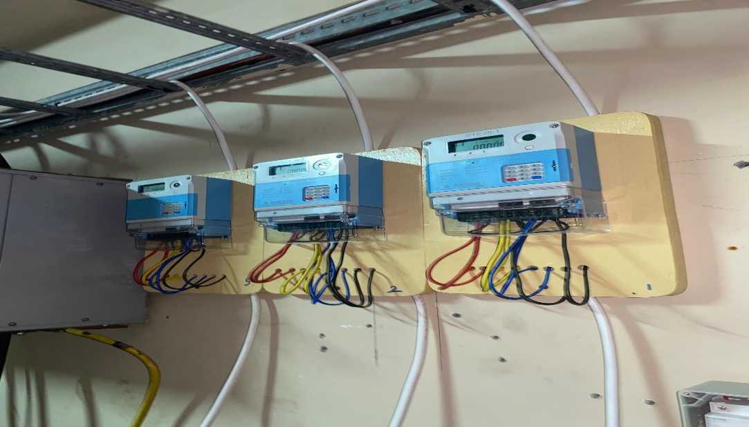
Three-phase CT meters at SSNIT Emporium, Airport City, Accra

Features and Specifications of LV CT Meter Unit

- Plug and play communication module
- High accuracy class
- Anti-tamper
- Maximum Demand measurement
- Exchangeable between postpaid and prepayment mode

The Technical Data Sheet- CT Meters

Electrical Parameters
Nominal Voltage |  | 3×230V
Working Voltage Range |  | 70%~120%Un
Nominal Frequency |  | 50-60Hz
Basic Current (Ib) |  | 1.5A
Maximum Current (Imax) |  | 6A
Starting Current (Ist) |  | 1.5mA
Active Energy Constant |  | 400imp/kWh
Active Energy Accuracy |  | Class 1.0
Reactive Energy Accuracy |  | Class 2.0
Power Consumption in Voltage Circuit |  | <2W <8VA
Power Consumption in Current Circuit |  | <1VA
Operation Temperature Range |  | -25℃-70℃
Storage Temperature Range |  | -40℃-85℃
Electro Magnetic Compatibility
AC Insulation Strength |  | 4kV at 50Hz during 1min
Impulse voltage 1.2/50 us mains connections |  | 8kV
Electrostatic Discharges | Contact discharge | 8kV
 | Air discharge | 16kV
Electromagnetic RF Field | 27MHz-500MHz | 10V/m
 | 100KHz-1GHz | 30V/m
Fast transient burst test |  | 4kV
Mechanical requirements
Meter shell Water proof protection Rate |  | IP54
Protection |  | Class II

1.7 The Meter functionalities
- A 20-digit STS encryption vending code generated for power recharge
- A robust enhanced tamper detection functionality to prevent meter bypass and tampering by tenants
- Provides Low credit warning level display
- Meter event recording features.
- Remote reading of each meter’s power balance and consumption status
- Exception reporting on disputed consumption of users
- Consumption statistics to track energy efficiency of users and the global consumption of the facility.

THE DATA CONCENTRATOR UNIT (DCU)

STC18-A smart data concentrator unit (DCU) is dedicated to Smart Metering application and designed as a gateway between metering devices and AMI/AMR system, the DCU creates two ways communication from metering points to AMI/AMR system.
It collects real time meter electricity consumption data to support AMI monitoring, control, and reporting. Each DCU can handle up to 300 pcs meters.

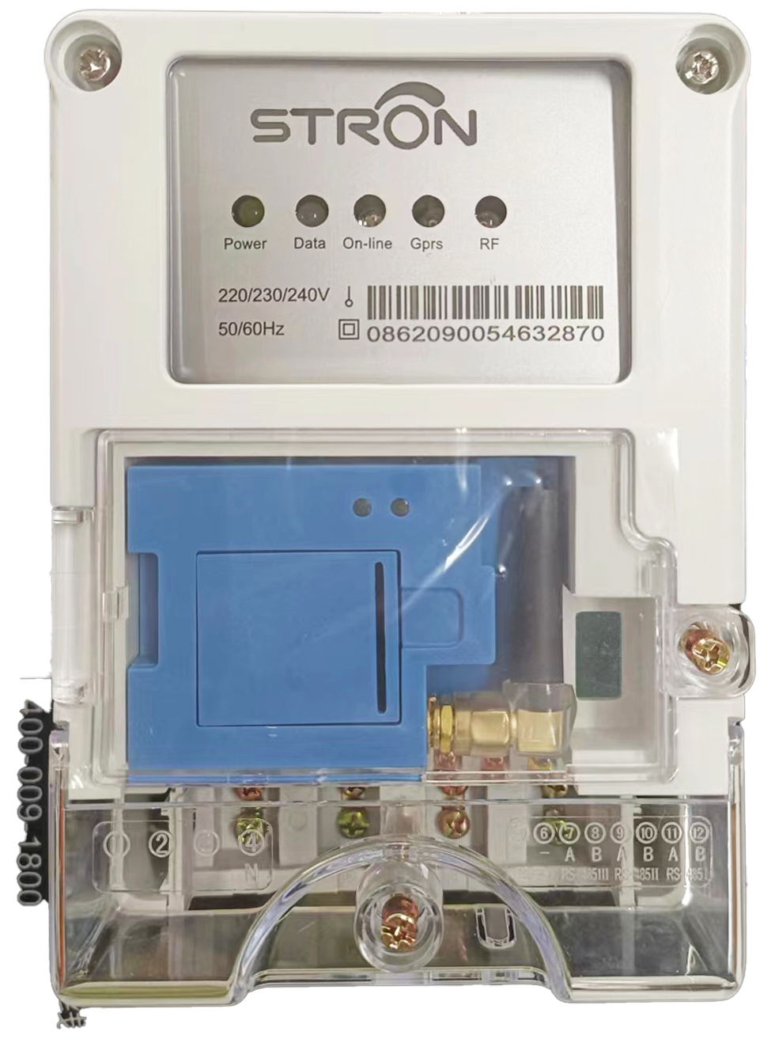

The Main features of the DCU
- DLMS/COSEM standard compliant
- RS485/RF-LORA downlink to smart meters
- GPRS/3G/DSL uplink communication with a head-end AMI/AMI system
- Data collection include total consumption/ historical daily & monthly consumption.
- Meter parameter/ status/ Real-time data reading
- Tamper event record and upload automatically House
- Easy to install due to BS mounting.

1.8 Payment Methods and Payment of Outstanding Bills

Payment for credit Top-up
The payment for recharge of meter credit will be strictly by Mobile Money (momo) from shop owners.

- Open a dedicated bank account with a reputable bank for deposit of payment electricity recharge.
- A dedicated Merchant Account will be created for deposit of monthly electricity bill payments (to be provided to shop-owners during sensitization meetings)
- Set up of on-site Points-of-sale (PoS) at strategic positions at Kumasi Central market for shop-owners to buy credit tokens.
- Provide Hotlines for shop owners access to sales points by phone
- Shop-owners will buy amount of credit of their choice by momo to the merchant account. The momo reference shall be the shop number identification.
- The momo transaction shall be sent to dedicated WhatsApp numbers (to be created)
- The Credit token will then be generated on the vending system upon verification of payment by shop-owner (mono reference number)
- The 20-digit token will then be forward to the shop-over to load to the meter by the unique CIU
- Receipts of payment shall be printed on request
- The vending system can be accessed 24/7 by shop-owners anywhere globally.

1.9 Tariff Structure

The tariff structure shall take into consideration the following:
- The PURC tariff for electric power consumption
- Common areas costs of the market complex
- Electricity line losses and system losses
- Software as Service (SaaS) for token generation and back-end support.

Key Milestones and Timelines

Activity Description | Start Date | End Date | Duration (weeks)
Pre-Installation: Phase 1
Contract Signing |  |  | 1 Week
Ordering of meters  (50% Deposit) |  |  | 2 Weeks
Meter Production |  |  | 8 weeks
Payment of 50% balance before shipping
Shipping to Tema port |  |  | 6 Weeks
Total of pre-installation |  |  | 17 weeks
Installation: Phase 2
Power supply and separation (if any) |  |  | 5 weeks
Installation of prepaid meters and equipment |  |  | 5 weeks
Sensitization of shop owners |  |  | 2 Weeks
Pilot Testing of meters and equipment credentials |  |  | 3 weeks
Project completion and handing over of sub-metering system
Total Installation:  Phase 2 |  |  | 15 weeks
Subject to change based on actual quantities of meters

3.0 Financial Proposal

3.1 Price Schedule
Item | Description | Unit Price (GHS)
1 | Prepaid Grid (ECG) Electricity Source Only
 | Single-phase prepaid meter with CIU | 1,018.20
 | Three-phase prepaid meter with CIU | 2,012.04
 | Three-phase LV prepaid Current Transformer with CIU | 24,006.24
2 | Prepaid Dual Electricity Source (ECG+ Generator)
 | Single-phase prepaid meter with CIU | 1,301.28
 | Three-phase prepaid meter with CIU | 2,355.24
 | Three-phase LV prepaid Current Transformer with installation accessories | 28,627.56
 | Data Concentrator Unit (DCU) | 3,600.00
3 | Prepaid Water
 | Prepaid Water meter with CIU | 2,034.00
4 | Other charges
 | Installation and deployment per meter | 200.60
 | Vending software license annual renewal (annual subscription) | 8,400.00
5 | Software as Service (SaaS) charges (monthly)
 | Charge on each transaction value | 0.35%
The prices (tax exclusive) are valid for 60 days from the date of this quotation.

3.2 Software as Service (SaaS) and IT Infrastructure Management

Xtopel will provide back-end IT and back-office support for the prepayment vending management software, customer management system (CMS), the token generator software maintenance and meter management services to maintain a seamless operation of the sub-metering e-payment system. Consequently, Software as Service (SaaS) maintenance and IT infrastructure support services will be charged upon installation of the sub-metering system.

4.0 About Xtopel Power Limited

Xtopel Limited is duly registered under the Registration of Business Names Act, 1962 Act 151) in 2018. Xtopel is a multidisciplinary company with three subsidiaries which operates in revenue management, management consultancy and energy solutions management.

Xtopel Power provides energy management solutions to the electricity SUBMETERING service industry to improve energy efficiency and guarantee electricity revenue collection assurance landlords, and facility managers of industry, commercial facilities, markets, malls, hostels and residential owners. The solution also provides convenience in power management to electricity consumers.
The technology, tools and systems provide for scientific electricity billing, revenue collection and control solutions. We deploy smart keypad prepaid metering system on automatic metering infrastructure (AMI) with automatic meter reading (AMR) technology supported by a vending system on our e-payment platform.

4.1 Sample of Selected Relevant Projects Undertaken by the Firm

- Projects running in the last 8 years

Project name and country | Name of employer and contact person | Type of services provided and year of completion
ADC Sub-metering; Accra | Ghana Digital Centers Limited (GDCL)  Contact person: Mr. Eric Mensah  Mob: 0243012882 | - Supply and installation of single-phase and 3-phase smart pre-paid meters, an independent vending management system with data concentration unit (DCU)  - Operational in 2018
Shippers House Sub-metering, Accra | Ghana Shippers Authority  Contact Person:  Mr. Bright Asubonteng Mob: 0243340314 | - Supply and installation of 3-phase smart pre-paid meters, an independent vending management system with data concentration unit (DCU)  - Operational in 2021
SSNIT EMPORIUM Submetering, Airport City, Accra | Social Security National Insurance Trust (SSNIT)  Contact Person:  Ms. Alberta Adofo  Mob. 0504493779 | - Supply and installation of single-phase and 3-phase smart pre-paid meters, an independent vending management system with data concentration unit (DCU)  - Completed in 2024
Vikings Hostel Submetering, University of Ghana, Legon, Accra | Vikings Hostels Limited, UG  Contact Person:  Ms. Gifty  Mob. 0244691684 | - Supply and installation of single-phase smart pre-paid meters, an independent vending management system with data concentration unit (DCU)  - Completed in 2025
Octagon Commercial building Sub-metering, Accra | Dream Realty Limited  Contact Person: Mazen El Katerji:  Mob: 0246757134 | - Installation BTU postpaid meters  - Operational in 2025

- Upcoming and Committed Services
Services under way or committed
Project name | Name of employer and contact person | Type of services to be provided | Expected completion date
University of Ghana Enterprises Limited (UGEL) Submetering | University of Ghana Enterprises Limited (UGEL)  Contact:  Mr. Richard | - Pilot installations of 1-phase prepaid meters at 7 hostels | 2022
Kumasi Central Market sub-metering  Project | Contracta Limited  Contact:  The Project Consultant  Mob: 0244804059 | - Installation smart single-phase and 3-phase prepaid meters  - Activation of vending management system | 2026
UCC sub-metering  Project | University of Cape Coast (UCC)  Contact: Mr. Benedict Addo-Yeboah  Mob: 0243703370 | - Installation smart single-phase and 3-phase prepaid meters  - Activation of vending management system | 2026
Takoradi Market Circle sub-metering  Project | Sekondi Takoradi Metropolitan Assembly (STMA)  Contact:  Mr. Michael Gyasi  Mob: 0244804059 | - Installation smart single-phase and 3-phase prepaid meters  - Activation of vending management system | 2026
Ghana Airports Company Limited (GACL) Submetering | Ghana Airports Company Limited  Contact:  Mr. Fynn | - Installation of 1-phase and 3-phase metering at Kumasi and Tamale Airports  - Pilot in 2026 | 2026

Services offered by Xtopel Power

- General electrical services
- Installation of electrical transformers
- Installation of electricity meters, both mechanical and prepayment meters.
- General electricity transmission line system improvement services
- Submetering of Prepaid meters and Vending management solutions
- Separation of Tenant Wiring in Commercial Facilities

5.0 XTOPEL SUB-METERING PROJECTS IN PICTURES

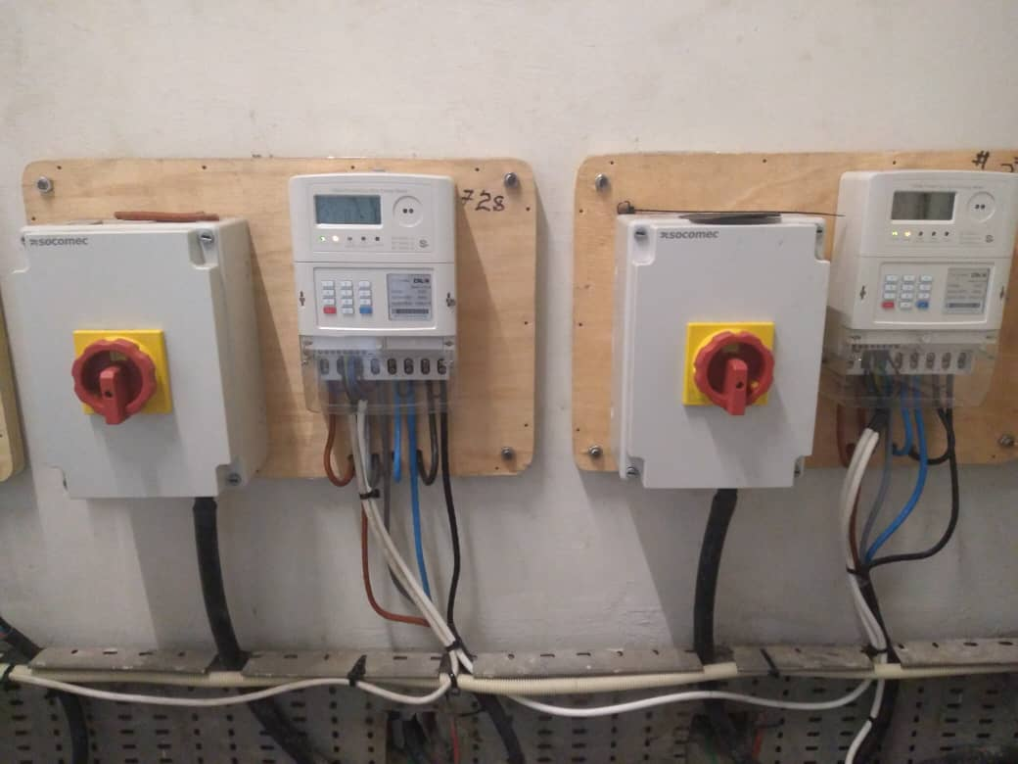
Ghana Shippers Authority dual tariff-prepaid meter Project operationalized in 2021

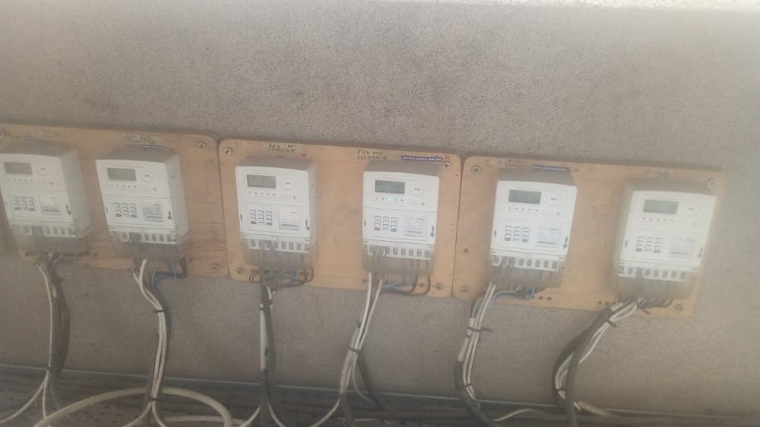

Ghana Shippers Authority dual tariff-prepaid tenants air-condition meters 2021

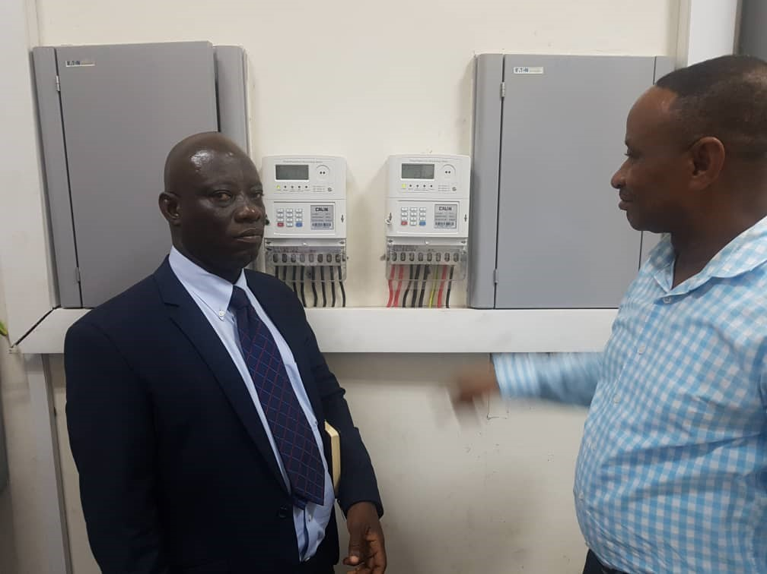
Accra Digital Center sub-metering system operationalized since 2018.

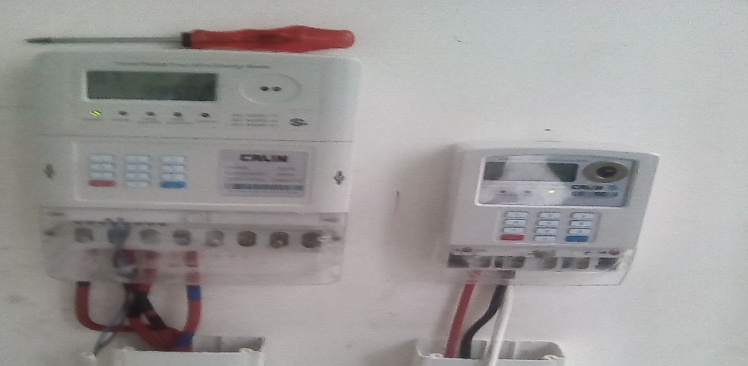
Dream Realty (Octagon) single-phase and Three-phase meters

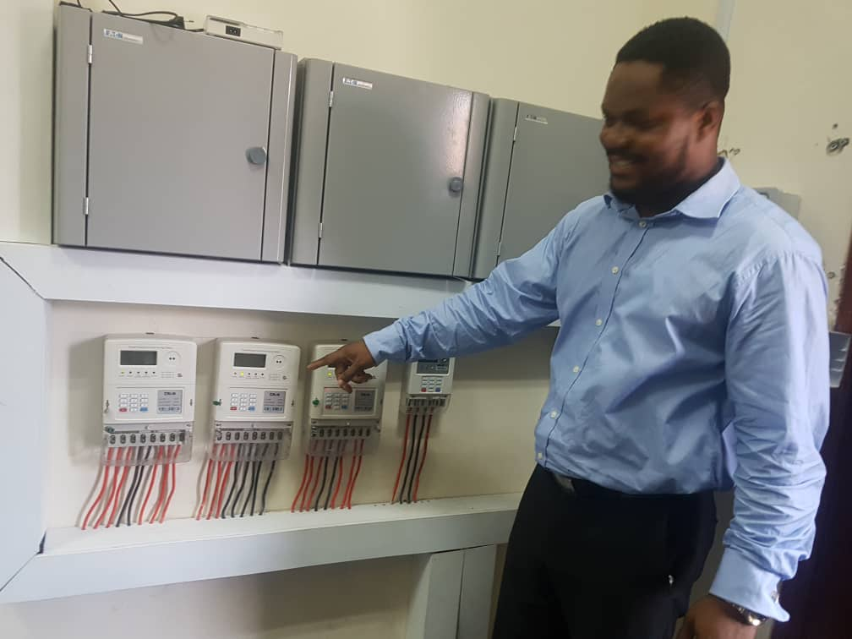

Single-phase meters at Accra Digital Center operationalized in 2018

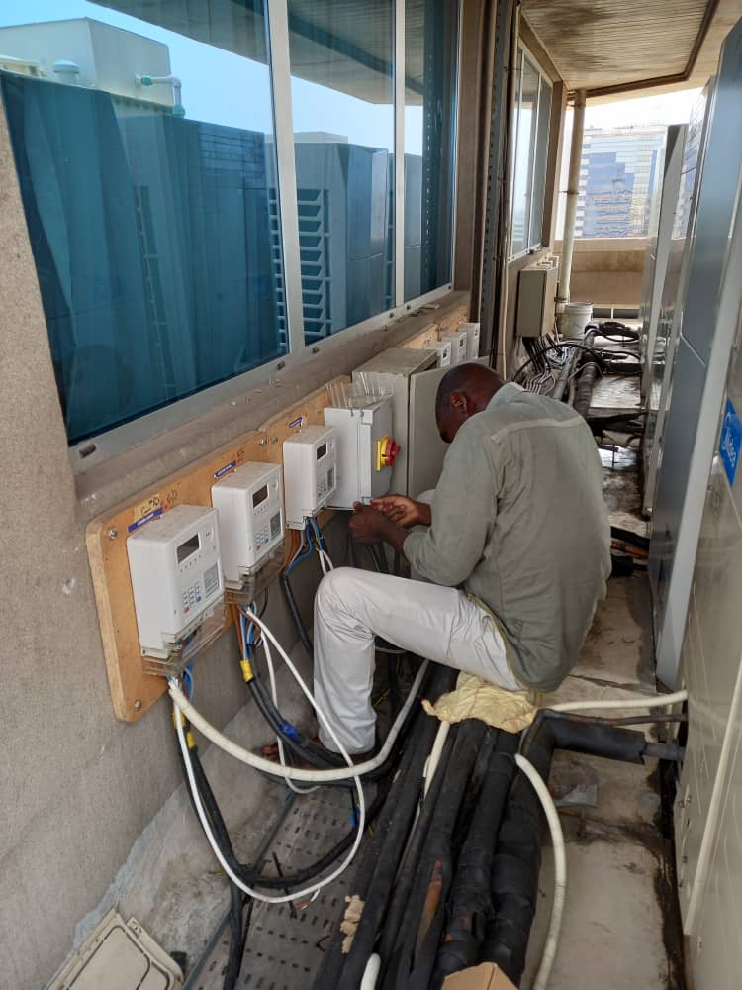

Meter installation at Shippers House (10th-floor) by our electrical technicians

